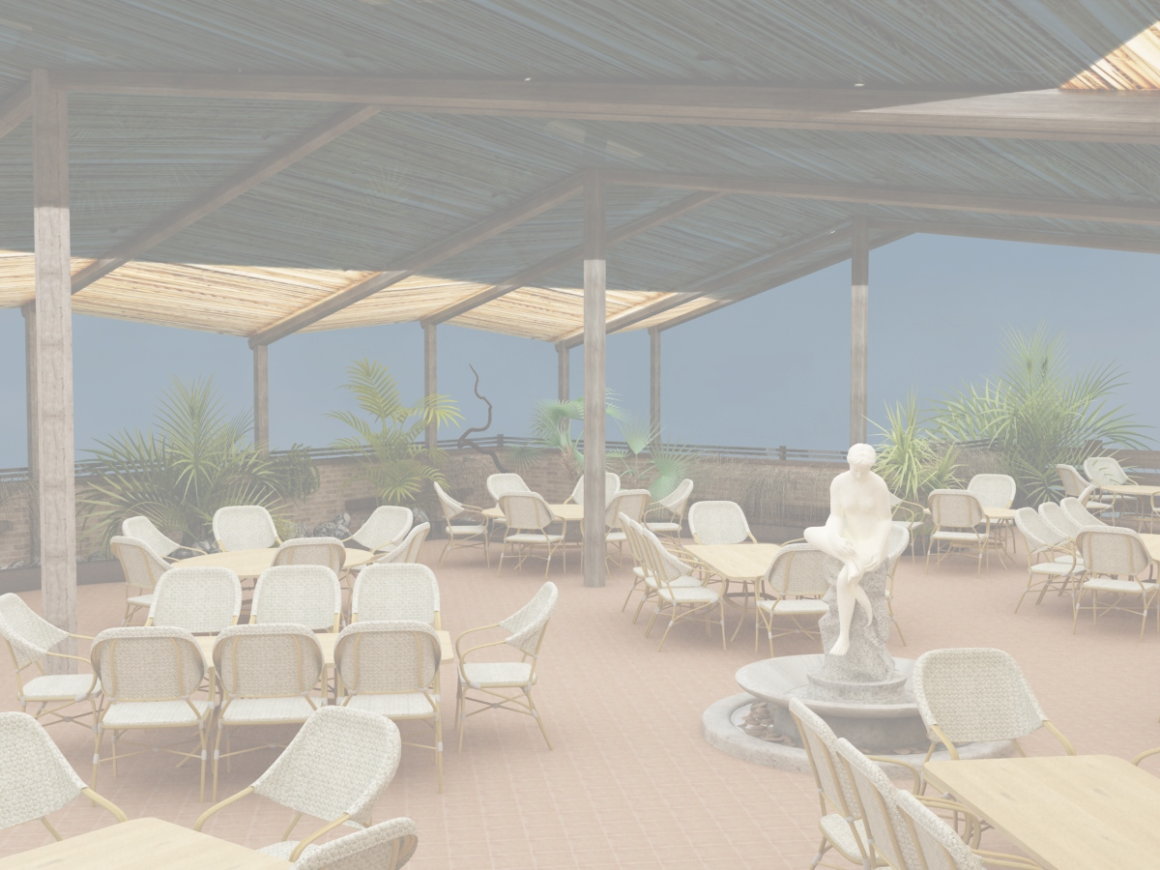
sendviCi
Sandwiches
klab sendviCi klasikuri samfenovani sendviCi, holandiuri yveli, salaTis foTlebi, lori Semwvari qaTmis file, bekonis Cifsi, maionezi da pomidori. |  |  |  |  |  | 12.50 | lari
Clasic Club Sandwich Triple-decker layered with, lettuce, Ementaler Cheese  mayonnaise, Crispy Bacon seared chicken fillet And Pickles. |  |  |  |  |  | 12.50 | GEL
tuna sendviCi: orfenovani sendviCi, pikuli, Tevzi Tinusi salaTi foToli, Tinusis pasta, pomodori, pikulis dekoracia |  |  |  |  |  | 13.50 | lari
Tuna Sandwich: Double- decket layered bread, Tuna Fish, mayones, Pickles, Tuna pasta, Tomato And Pickles Decor. |  |  |  |  |  | 13.50 | GEL
krok madam sendviCi tostis puri, Semwvari qaTmis mkerdi, maionezi, bekonis Cifsi, yveli, Semwvari kvercxiTa da pomidori |  |  |  |  |  | 13.50 | lari
Crock Madam Sandwich Triple-decker layered with crispy bacon, lettuce, mayonnaise, seared chicken breast, fried egg and tomato |  |  |  |  |  | 13.50 | GEL
yvela sendviCs Tan axlavs kartofili fri da keCupi
All Sandwiches Are Served With French Frice And ketchup

ZiriTadi kerZebi
Main Dishes
"niu-ourk" steiki saqonlis sukis sokos sousiT |  |  |  |  |  | 22.00 | lari
Beef Fillet With Mushroom Sauce |  |  |  |  |  | 22.00 | GEL
xbos steiki Rvinis sousiT brinjis an bostneulis asortis garniriT |  |  |  |  |  | 22.00 | lari
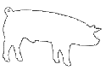  Veal fillet With Wine Sauce, Garnished With Rice or Assort of Vegetables |  |  |  |  |  | 22.00 | GEL
steiki "France" grilze SemwvariqaTmis file sokos da yvelis sousi |  |  |  |  |  | 22.00 | lari
"France " Stake Grilled Chicken Fillet With Mushroom And Cheese Sauce |  |  |  |  |  | 22.00 | GEL
T-Bone steiki Roris anrtikoti salsas sousis da meqsikuri kartofili, |  |  |  |  |  | 18.00 | lari
T-Bone Stake Grilled Pork Enrticote With Salsa Sauce And Mexican Potato |  |  |  |  |  | 18.00 | GEL
saqonlis files medalionibekoniT, yvelis sousi da garniris brinjiT |  |  |  |  |  | 22.00 | lari
Beef Fillet Medalion Wripped In Bacon And Served With Cheese Sauce And Rice |  |  |  |  |  | 22.00 | GEL
oragulis steiki xizilalis sousiT da gamomcxvari kartofilis garniriT |  |  |  |  |  | 30.00 | lari
Salmon Stake Grilled salmon Fillet With Red Covior Sauce And Garnished With Baced Potato |  |  |  |  |  | 30.00 | GEL
Savi vefxisebri krevetebi sal-marilios sousiT |  |  |  |  |  | 24.00 | lari
Black Tiger Prawns With Sall Marilio Sauce |  |  |  |  |  | 24.00 | GEL
kalmari naRebis da soios sousiT, moxarSuli kartofiliT |  |  |  |  |  | 19.80 | lari
Trout Fried Served With Saio Cream Sauce And Boiled potato |  |  |  |  |  | 19.80 | GEL
kievuri katleti |  |  |  |  |  | 10.00 | lari
Chicken "Kiev" crumbed chicken breast filled |  |  |  |  |  | 10.00 | GEL
sokos Julieni araJaniT |  |  |  |  |  | 5.50 | lari
“Julienne” Field Mushroom In Sour cream sauce |  |  |  |  |  | 5.50 | GEL
xbos mwvadi Samfurze xaxvis da broweulis dekoraciiT |  |  |  |  |  | 12.00 | lari
Veal “Shashlick” Decorated With onion And pomegrameate grains on spit cooked on the charcoals |  |  |  |  |  | 12.00 | GEL
Roris xorcis mwvadi |  |  |  |  |  | 10.00 | lari
Pork Shashlik |  |  |  |  |  | 10.00 | GEL
cxare  spice | vegeterianuli  vegetarian | alkoholuri  Cortains alcohol | Roris xorci  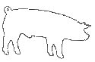  pork |  18:00 saaTamde Till 18:00
visac dietis an alergiis gamo surs icodes sakvebis Semadgenloba, gTxovT mimarToT mimtans
For those with special dietary requirements or allergies, please ask our waiter for assistance
momsaxureoba=15%
Service charge-15%

