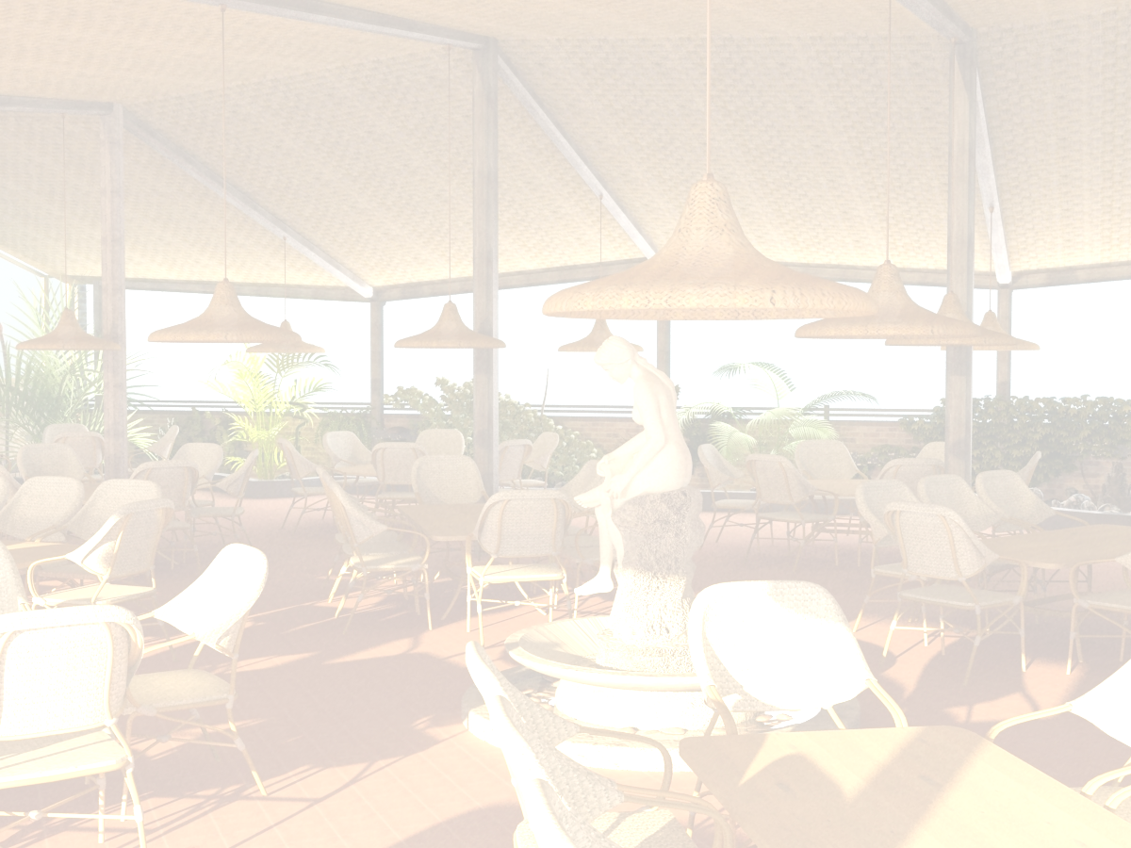
deserti
Dessert
xilis asorti |  |  |  |  |  | 20.00 | lari
Assort Of Fruit |  |  |  |  |  | 20.00 | GEL
xilis salaTi |  |  |  |  |  | 6.00 | lari
Fruit Salad |  |  |  |  |  | 6.00 | GEL
Semwvari banani Sokoladis sousSi |  |  |  |  |  | 7.50 | lari
Fried Banana With Chocolate Sauce |  |  |  |  |  | 7.50 | GEL
nayini vanilis,Sokoladis |  |  |  |  |  | 5.00 | lari
Ice Cream Chocolate, Vanilla |  |  |  |  |  | 5.00 | GEL
nayini kuragiT,qiSmiSiT,TxiliT |  |  |  |  |  | 6.50 | lari
Ice Cream With |  |  |  |  |  | 6.50 | GEL
nayini xiliT |  |  |  |  |  | 6.50 | lari
Ice Cream With Fruit |  |  |  |  |  | 6.50 | GEL
nayini romiT |  |  |  |  |  | 8.50 | lari
Ice Cream With Rum |  |  |  |  |  | 8.50 | GEL
nayini jemiT, musiT |  |  |  |  |  | 6.50 | lari
Ice Cream With Jam, Mouse |  |  |  |  |  | 6.50 | GEL
nayini beilisiT |  |  |  |  |  | 8.50 | lari
Ice Cream With Baylic |  |  |  |  |  | 8.50 | GEL
nayini Sokoladis topikiT |  |  |  |  |  | 6.50 | lari
Ice Cream With Chocolate Topic |  |  |  |  |  | 6.50 | GEL
tiramisu |  |  |  |  |  | 12.00 | lari
Tiramisu |  |  |  |  |  | 12.00 | GEL
namcxvari |  |  |  |  |  | 7.50 | lari
Cake |  |  |  |  |  | 7.50 | GEL
Sokoladis fila |  |  |  |  |  | 3.50 | lari
Chocolate |  |  |  |  |  | 3.50 | GEL
miwis Txili |  |  |  |  |  | 4.00 | lari
Pin Nuts |  |  |  |  |  | 4.00 | GEL
fistaSka |  |  |  |  |  | 5.50 | lari
Pistachio |  |  |  |  |  | 5.50 | GEL
Cifsi |  |  |  |  |  | 6.50 | lari
Chips |  |  |  |  |  | 6.50 | GEL
qarTuli Txili |  |  |  |  |  | 6.00 | lari
Georgian Nuts |  |  |  |  |  | 6.00 | GEL
cxare  spicy | vegeterianuli  vegetarian | alkoholuri  Cortains alcohol | 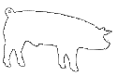  Roris xorci  pork |  |  18:00 saaTamde Till 18:00
visac dietis an alergiis gamo surs icodes sakvebis Semadgenloba, gTxovT mimarToT mimtans
For those with special dietary requirements or allergies, please ask our waiter for assistance
momsaxureoba=15%
Service charge-15%

