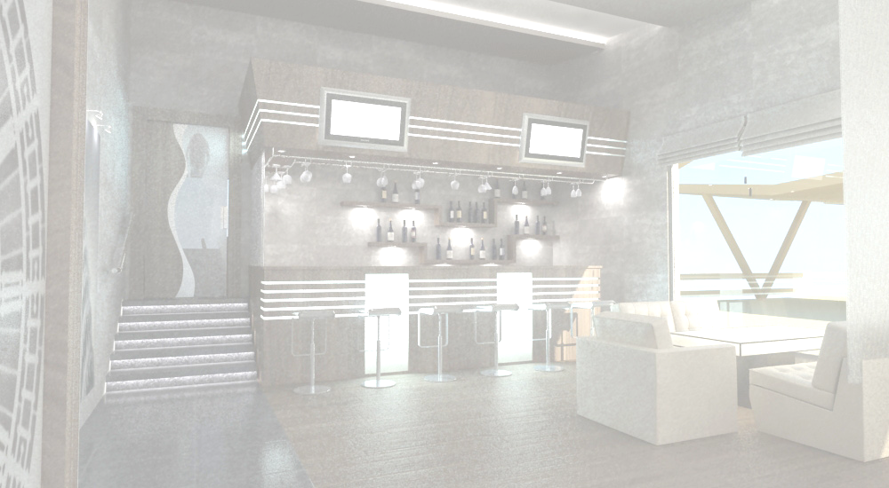
nakverCxalze Semwvari kerZebi
FROM THE BBQ
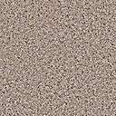wiwila Semwvari nakverCxalze |  |  |  |  |  |  |  |  | 16.00 | lari
Baby-Chicken Fried on the charcoals |  |  |  |  |  |  |  |  | 16.00 | GEL
mwyeri Semwvari nakverCxalze |  |  |  |  |  |  |  |  | 5.00 | lari
Fried Quail on the charcoals |  |  |  |  |  |  |  |  | 5.00 | GEL
qaTmis mwvadi |  |  |  |  |  |  |  |  | 5.50 | lari
Chicken “Shashlick” Cooked in BBQ Sauce, fried on hot charcoals |  |  |  |  |  |  |  |  | 5.50 | GEL
indauris mwvadi |  |  |  |  |  |  |  |  | 15.00 | lari
Turkey “Shashlick” Cooked in Beer Sauce, ried on hot charcoals |  |  |  |  |  |  |  |  | 15.00 | GEL
xbos mwvadi Samfurze xaxvis da broweulis dekoraciiT |  |  |  |  |  |  |  |  | 12.00 | lari
Veal “Shashlick” Decorated With onion And pomegrameate grains on spit cooked on the charcoals |  |  |  |  |  |  |  |  | 12.00 | GEL
RviZli bade qonSi |  |  |  |  |  |  |  |  | 12.00 | lari
liver Stuffed in fat minceneat fried on hot charcals |  |  |  |  |  |  |  |  | 12.00 | GEL
batknis mwvadi Samfurze xaxvis da broweulis dekoraciiT |  |  |  |  |  |  |  |  | 15.00 | lari
Lamb” Shashlick” Decorated With onion And pomegranate grains Fried on the charcoals |  |  |  |  |  |  |  |  | 15.00 | GEL
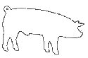  Roris suki bade-qonSi |  |  |  |  |  |  |  |  | 14.00 | lari
Pork Fillet, Stuffed in fat mincemeat fried on hot charcals fried on hot charcoals |  |  |  |  |  |  |  |  | 14.00 | GEL
Roris xorcis mwvadi |  |  |  |  |  |  |  |  | 10.00 | lari
Pork Shashlik |  |  |  |  |  |  |  |  | 10.00 | GEL
oragulis mwvadi nakverCxalze |  |  |  |  |  |  |  |  | 20.00 | lari
Salmon “Shashlick” fried on hot charcoals |  |  |  |  |  |  |  |  | 20.00 | GEL
zuTxis mwvadi Samfurze |  |  |  |  |  |  |  |  | 45.00 | lari
Stargeon “Shashlick” on spit fried on hot charcoals |  |  |  |  |  |  |  |  | 45.00 | GEL
norvegiuli TarTis mwvadi |  |  |  |  |  |  |  |  | 13.00 | lari
Norvegian Sturgeon “Shashlick” |  |  |  |  |  |  |  |  | 13.00 | GEL
lula qababi |  |  |  |  |  |  |  |  | 10.00 | lari
"Lula-Qebab" Fried Beef And Pork Wipped In Lavashi Bread |  |  |  |  |  |  |  |  | 10.00 | GEL
bostneulis mwvadi |  |  |  |  |  |  |  |  | 6.00 | lari
Vegetable "Shashlick" |  |  |  |  |  |  |  |  | 6.00 | GEL
garnirebi
Side Dishes
kartofili "fri" |  |  |  |  |  |  |  |  | 4.00 | lari
French Fries |  |  |  |  |  |  |  |  | 4.00 | GEL
kartofili xaxvSi Semwvari |  |  |  |  |  |  |  |  | 3.50 | lari
Potato fried in onion |  |  |  |  |  |  |  |  | 3.50 | GEL
RumelSi Semwvari mundiriani kartofili |  |  |  |  |  |  |  |  | 3.00 | lari
Backed Potato |  |  |  |  |  |  |  |  | 3.00 | GEL
kartofilis piure |  |  |  |  |  |  |  |  | 3.00 | lari
mashed potatoes, |  |  |  |  |  |  |  |  | 3.00 | GEL
brinji moxarSuli |  |  |  |  |  |  |  |  | 3.00 | lari
Steamed Rice |  |  |  |  |  |  |  |  | 3.00 | GEL
brinji bostneuliT |  |  |  |  |  |  |  |  | 4.00 | lari
Rice With Vegetable |  |  |  |  |  |  |  |  | 4.00 | GEL
moTuSuli bostneuli |  |  |  |  |  |  |  |  | 4.50 | lari
Pen Fried Vegetable |  |  |  |  |  |  |  |  | 4.50 | GEL
brokoli moxarSuli |  |  |  |  |  |  |  |  | 4.50 | lari
Steamed Vegetables |  |  |  |  |  |  |  |  | 4.50 | GEL
bostneuli grilze Semwvari: badrijani,qama soko,bulgaruli wiwaka |  |  |  |  |  |  |  |  | 6.50 | lari
Griled Vegetables: Eggplant, Mushroom,Bulgar pepper |  |  |  |  |  |  |  |  | 6.50 | GEL
saweblebi
Sauces
tyemali |  | 1.00 | lari |  | baJe |  |  |  | 4.00 | lari
Wild Plum Sauce |  | 1.00 | GEL |  | "Baje" Walnut Sauce |  |  |  | 4.00 | GEL
pomidvris sawebeli |  | 1.00 | lari |  | qinZmari nigvziT |  |  |  | 1.50 | lari
Tomato Sause |  | 1.00 | GEL |  | Coriander sauce with walnut |  |  |  | 1.50 | GEL
naSarafi |  | 1.50 | lari |  | ajika |  |  |  | 1.00 | lari
Pomegranate Sauce |  | 1.50 | GEL |  | Chili Pepper Sauce |  |  |  | 1.00 | GEL
cxare  spicy | vegeterianuli  vegetarian |  | alkoholuri  Cortains alcohol |  | Roris xorci  pork | 18:0 Till  18:000 saaTamde
momsaxureoba-15%
Service charge-15%

